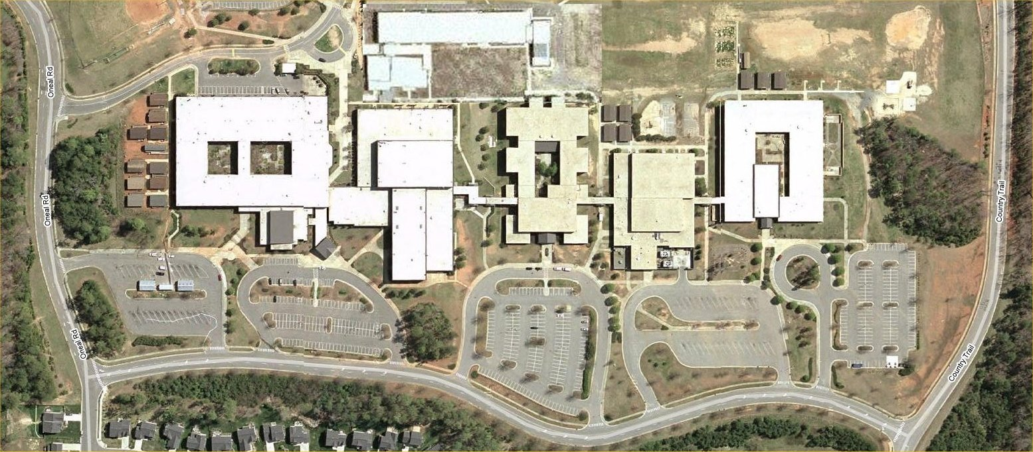
High School
Elementary
School
Tag’Em Div 1,2,3 Drop Off
Tag’Em Div 2,3
Multi-Purpose
Around the World
Div 1 – Auditorium
Around the World
Div 1 – Drop Off
Around the World
Div 3 Drop Off
Around the World…
Div 3 – Med Cent
Only Thinking…
Div 1,3 – Drop Off
Only Thinking
Div 3 – Art Rm
Only Thinking…
Div 2 – ES Multi-Purp
Only Thinking…
Div 2 – Drop Off
Out of the Box
Main Gym

Large & Small…
Div 1 – MS Gym
Large & Small…
Div 1 – Drop Off
Tag’Em
Div 1
Aux Gym
Large & Small…
Div 2,3 – Rm 210
Middle
School
High School
Around the World
Div 2 – Med Cent
Around the World
Div 2 – Drop Off
Out of the Box
Drop Off

To
Leesville
Road

Team & Volunteer
Registration
Out of the Box
Weigh-In Rm 35

Official’s Registration
Rm 130
Souvenirs
Museum
Cafeteria
Only Thinking…
Div 1 – Med Cent
Awards Ceremony
Main Gym
Spontaneous
Check-In
ProblemDiv.LocationSign Color#1 Tag’Em1HS - Aux GymOrange#1 Tag’Em2 & 3HS - Multi PurposeOrange#2 Large & Small of It1MS - GymPink#2 Large & Small of It2 & 3MS – Room 210Pink#3 Around the World..1HS - AuditoriumGreen#3 Around the World..2MS - Media CenterGreen#3 Around the World..3HS - Media CenterGreen#4 Out of the BoxAllHS - GymBlue#4 Weigh-inAllHS - Room 35Blue#5 I’m Only Thinking…1ES - Media CenterYellow#5 I’m Only Thinking…2ES- Multi PurposeYellow#5 I’m Only Thinking…3ES- Art Room 111Yellow#S SpontaneousAllHS - Spont Check In
North Carolina Odyssey of the Mind
State Tournament ~ March 31, 2007
Celebrating 25 Years Of Creativity
1982 - 2007
Leesville School Complex
North
MS / ES
Multi Use
Building

